EnterPrise App Dev Lab 2

Andrew Cosgrave lyons

C14574063

Unrestricted route localhost:3000/user

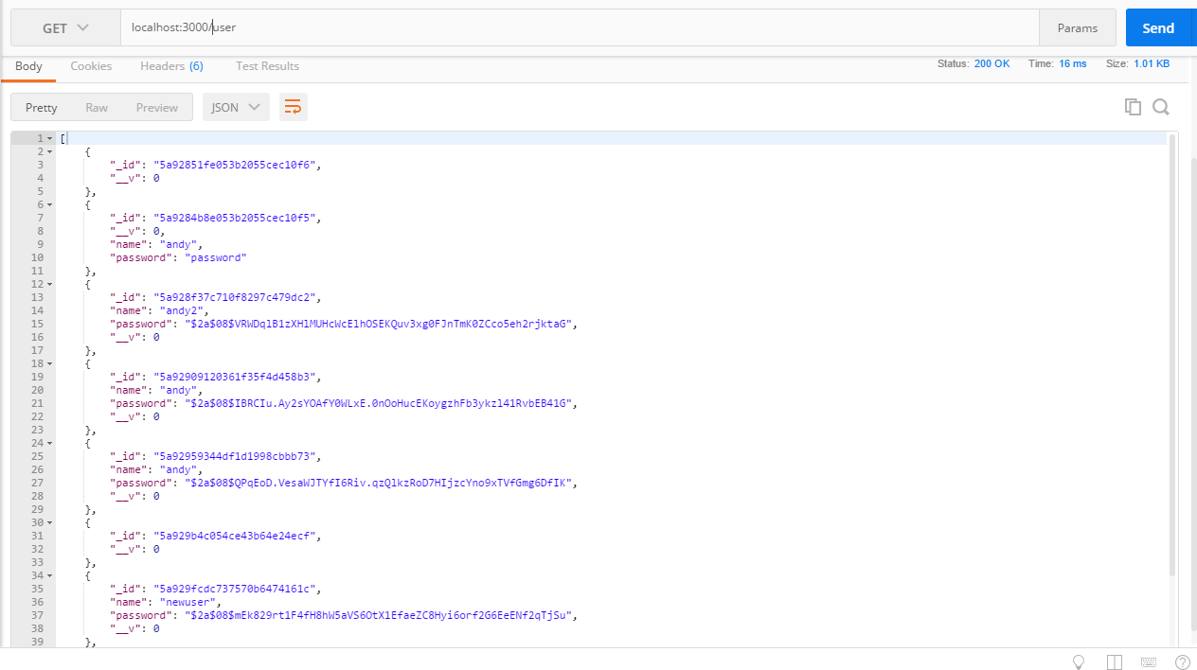

Register a user and get a token back

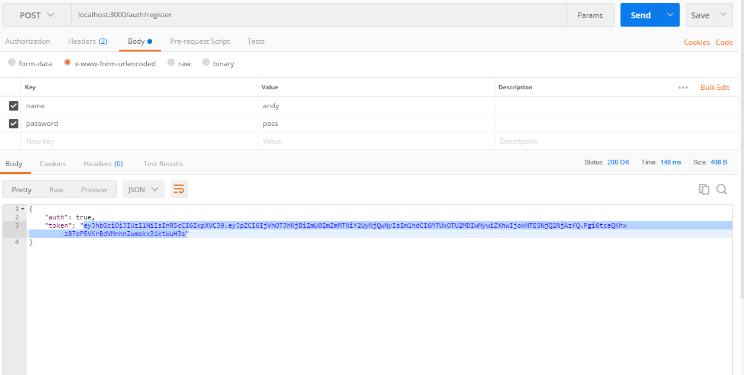

Try to view products table without sending token

Localhost:3000/auth/me2

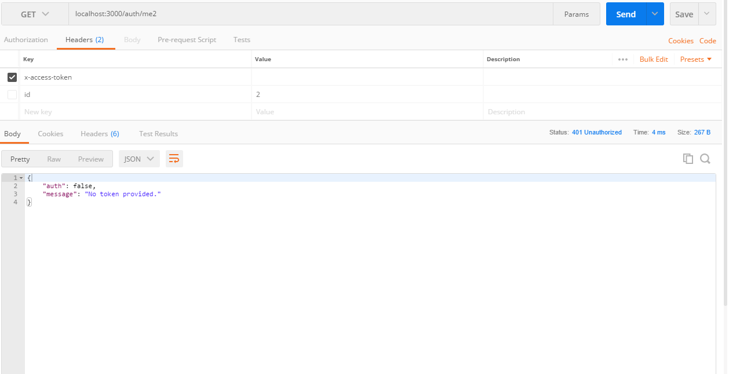

Try to view products route, this time send token in the req body

